TEAM ID: IBM-EPBL/IBM-Project-44288-1660723753

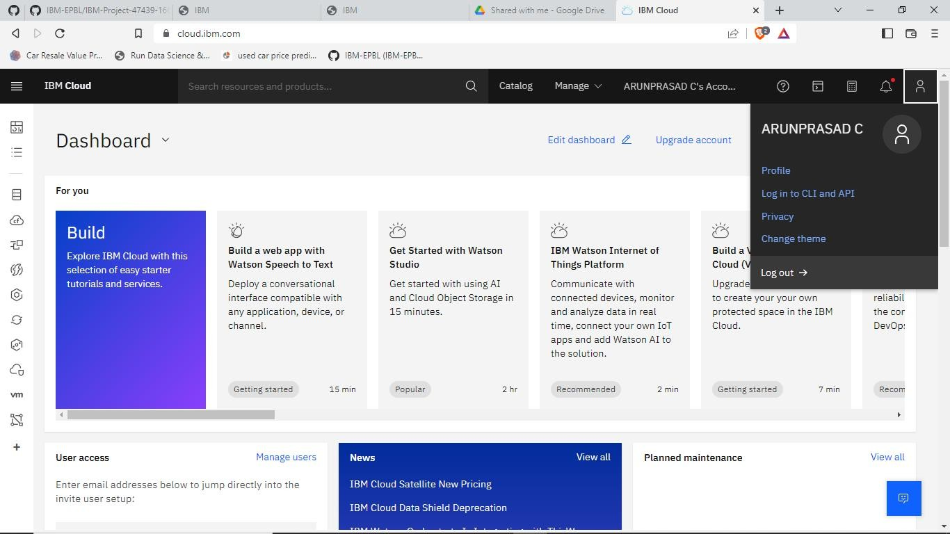

VASUDEVAN V CLOUD ACCOUNT

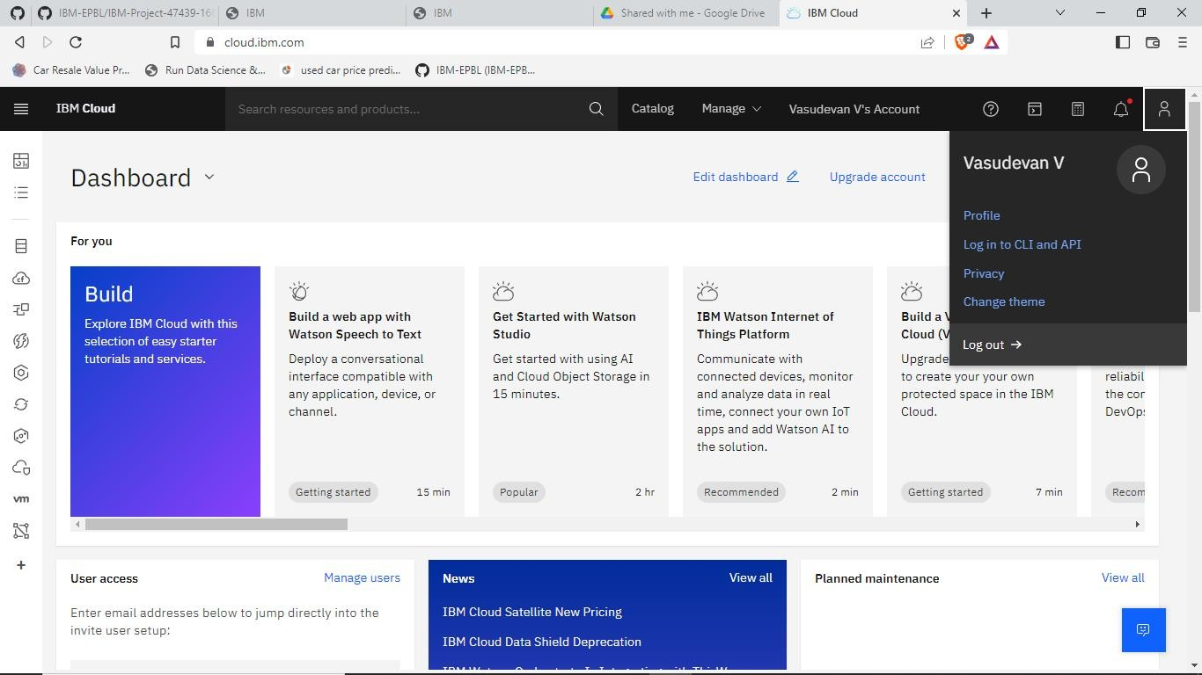

KAVIYARASAN M CLOUD ACCOUNT

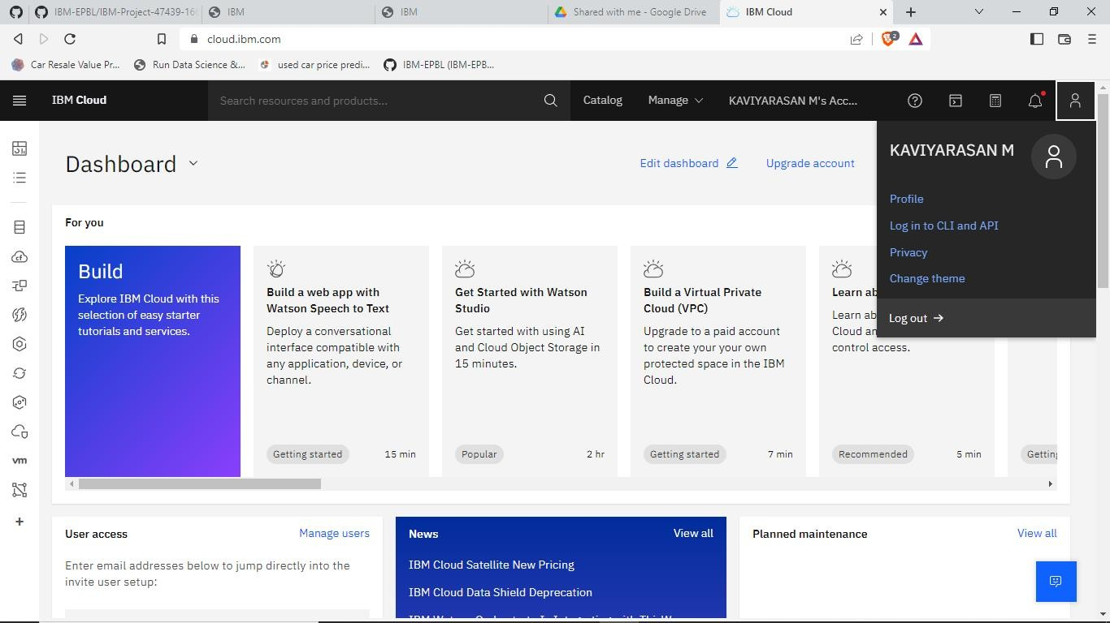

RAGUL K CLOUD ACCOUNT

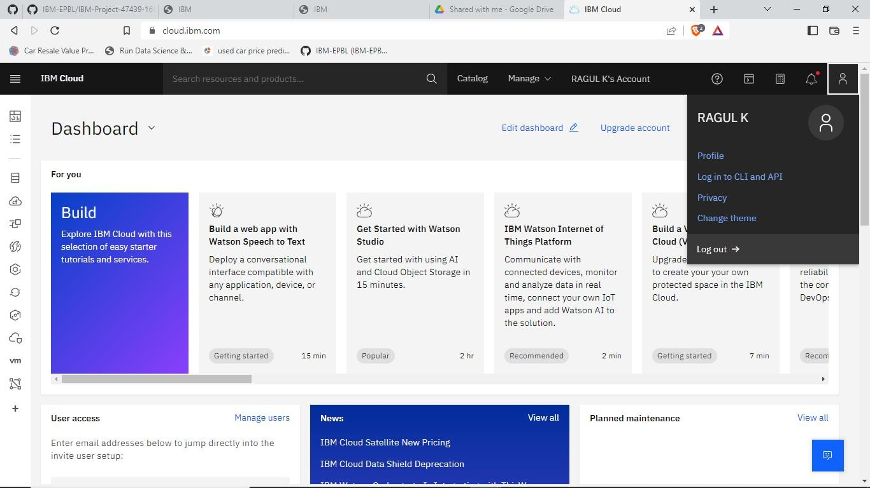

MANIKANDAN K CLOUD

